METHODOLOGY
The SARS-CoV2 data (as at 6th January, 2021) was downloaded from github, while the population data was downloaded from www.worldometer.com. R 4.0.3 software (R Core Team, 2020) was used for the statistical analysis. The R packages used are maptools (Roger & Nicholas, 2020), RColorBrewer (Erich, 2014), maps (Deckmyn et al., 2018), mapdata (Becker & Wilks, 2018), readxl (Wickham & Jennifer Bryan, 2019), ggplot2 (Kassambara, 2019), qwraps2 (Peter DeWitt, 2020), dplyr (Hadley et al., 2020), gridExtra (Auguie, 2017), ggcorrplot (Kassambara, 2019), ggpubr (Kassambara, 2020), gridExtra (Auguie, 2017), tidyr (Wickham & Lionel Henry, 2020), scatterpie (Guangchuang, 2020), ggmap (Kahle & Hadley Wickham, 2013), and mapproj (McIlroy et al., 2020) .
The various R packages (libraries) were loaded and the SARS-CoV2 data file from github was read in as “raw_data”, while the data file from worldometer was read in as africa_ncdc. The files formats were then changed to data frame. The data and the R script for the analysis can be accessed at https://github.com/Yinkaokoh/updatedSARCoV2_project
VISUALIZATIONS OF THE COLLECTE DATA
So many lineages. They are 782 pangoln lineages, 9 GISAID clades and 10 nextstrain clades. Europe submitted over 50% of the SARS-CoV2 sequences in GISAID as shown in Figure 1.
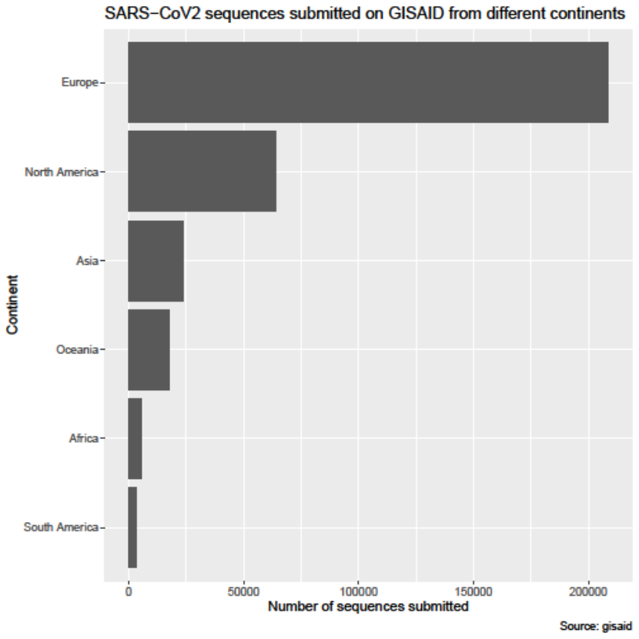
Figure 1A: SARS-CoV2 sequences submitted on GISAID
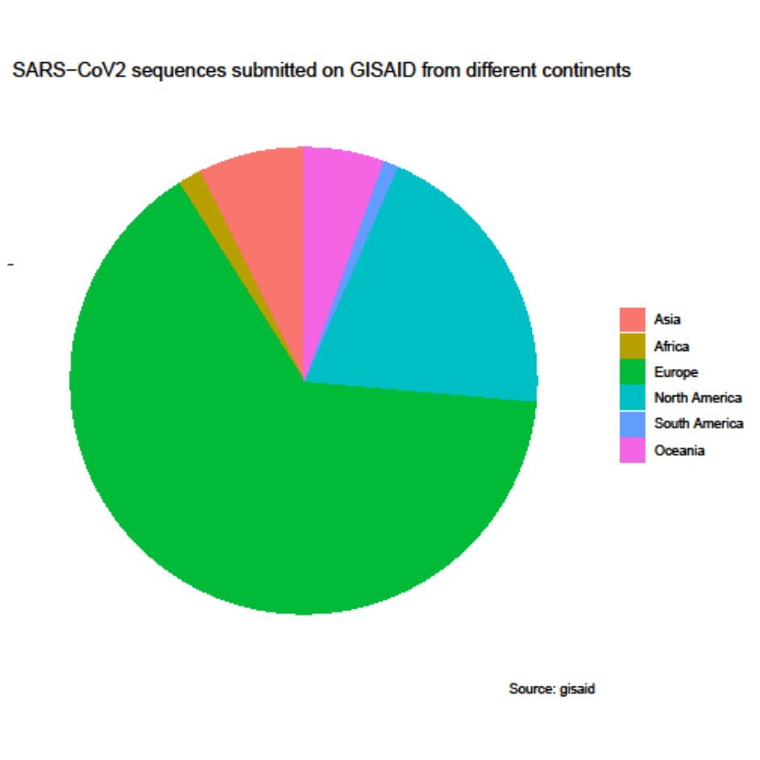
Figure 1B: SARS-CoV2 sequences submitted on GISAID

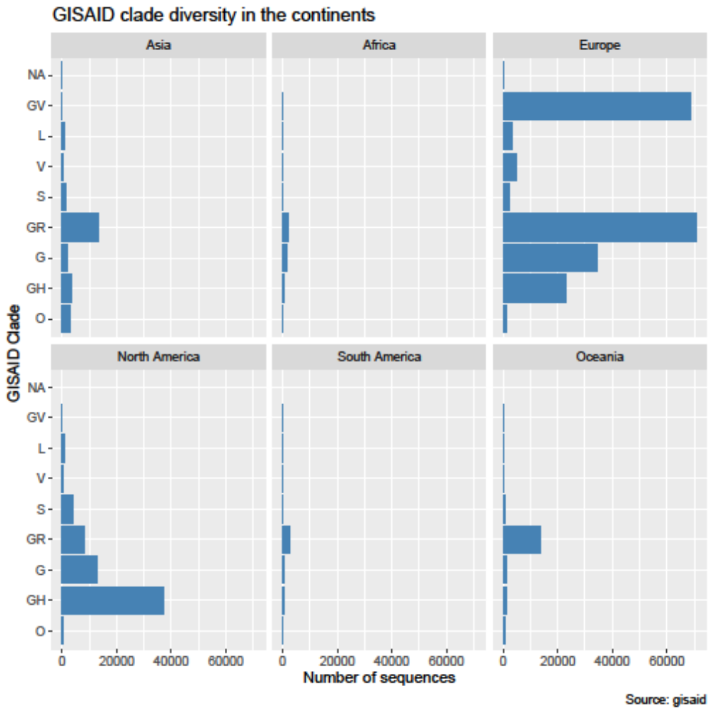
Figure 2: GISAID clades diversity
Looking at the GISAID clades diversity as shown in Figure 2, GR is the highest and followed by GV in Europe. For North America it is GH, while for Africa and Oceania it is GR.

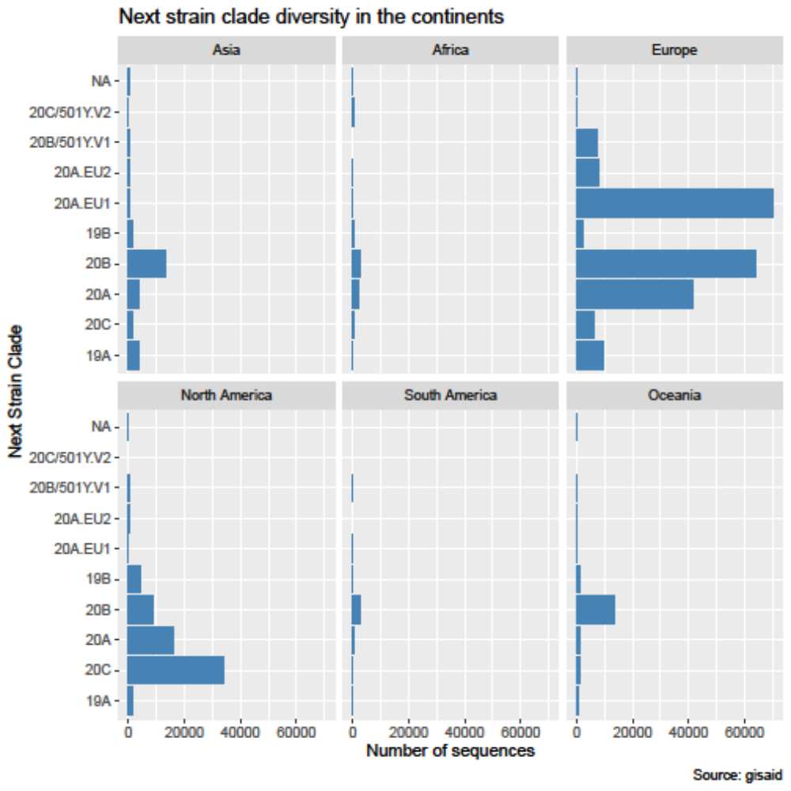
Figure 3: Nextstrain clades diversity.

Looking at the nextstrain clades as shown in Figure 3, 20EU1 is the highest in followed by 20B and 20A with each above 40,000 cases in Europe. 20C and 20A are the predominant nextstrain clades in North America, while 20B is the predominant clades in Africa and Oceania.

The lineages are very many, 782. So showing their distribution or diversity in one figure will not be meaningful. We consequently show the most prevalent ones. The top 1% is shown in Figure 4A while the 2nd, 3rd and 4th 1% are shown in Figures 4B, 4C and 4D.

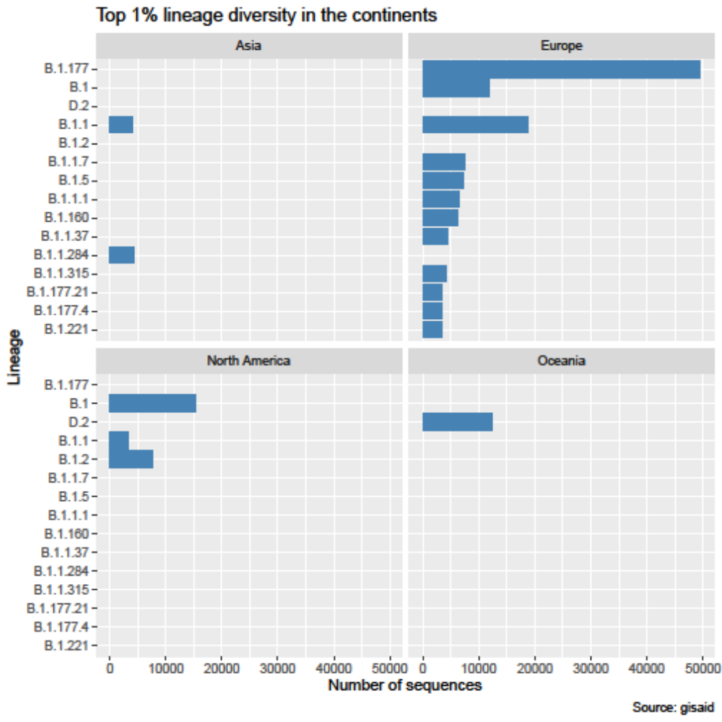
Figure 4A: Pangolin lineage diversity. Europe has the most diversified lineages with B.1.177 being the highest followed by B.1.1 and B.1. B.1.1 and B.1.1.284 are prevalent lineages in Asia while D.2 is the most prevalent in Oceania; B.1, B.1.2 and B.1.1 are prevalent in North America. Africa has none in the top 1% of lineages.

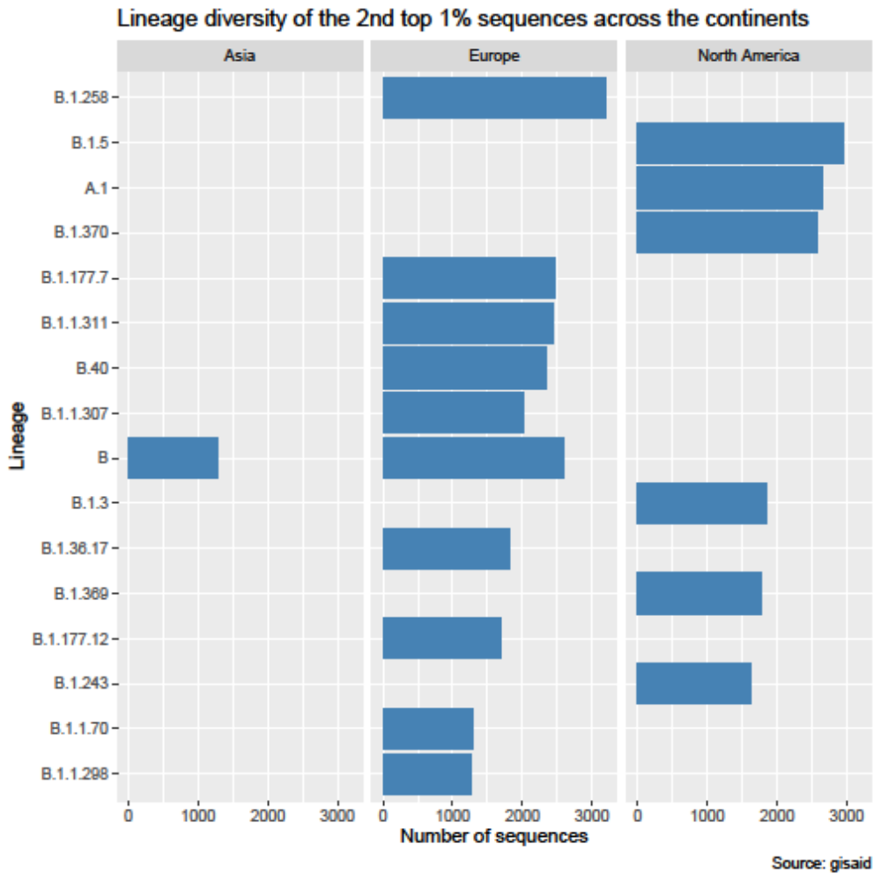
Figure 4B: The 2nd top 1% lineages are majorly in Europe and North America with just a single one, which is lineage B, in Asia.
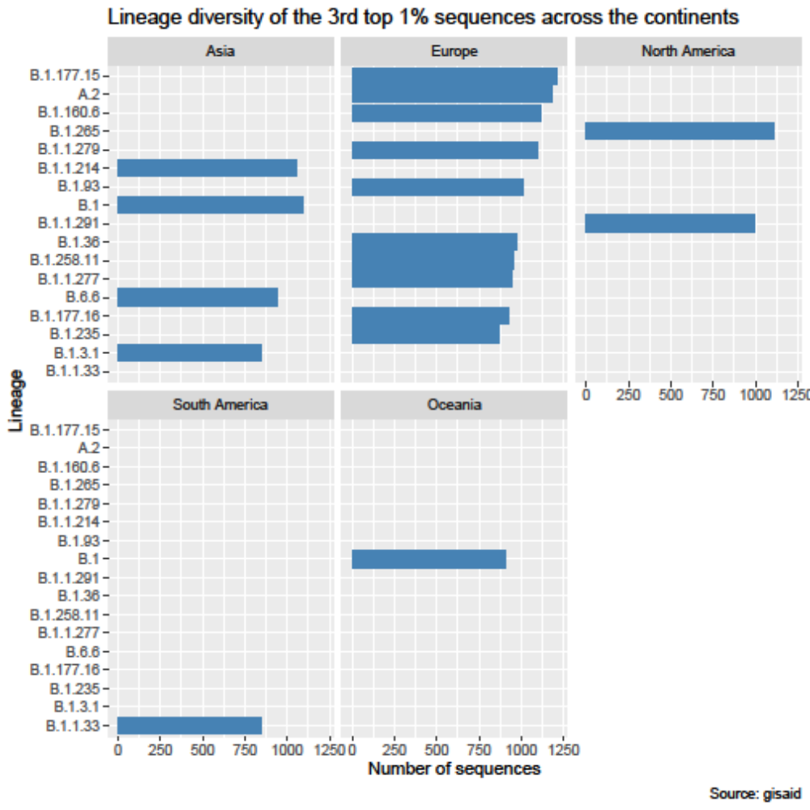
Figure 4C: The 3rd top 1% lineages has just one lineage in South America (B.1.1.33) and Oceania (B.1) each, two in North America (B.1.265 and B.1.1.291), four in Asia and ten in Europe.

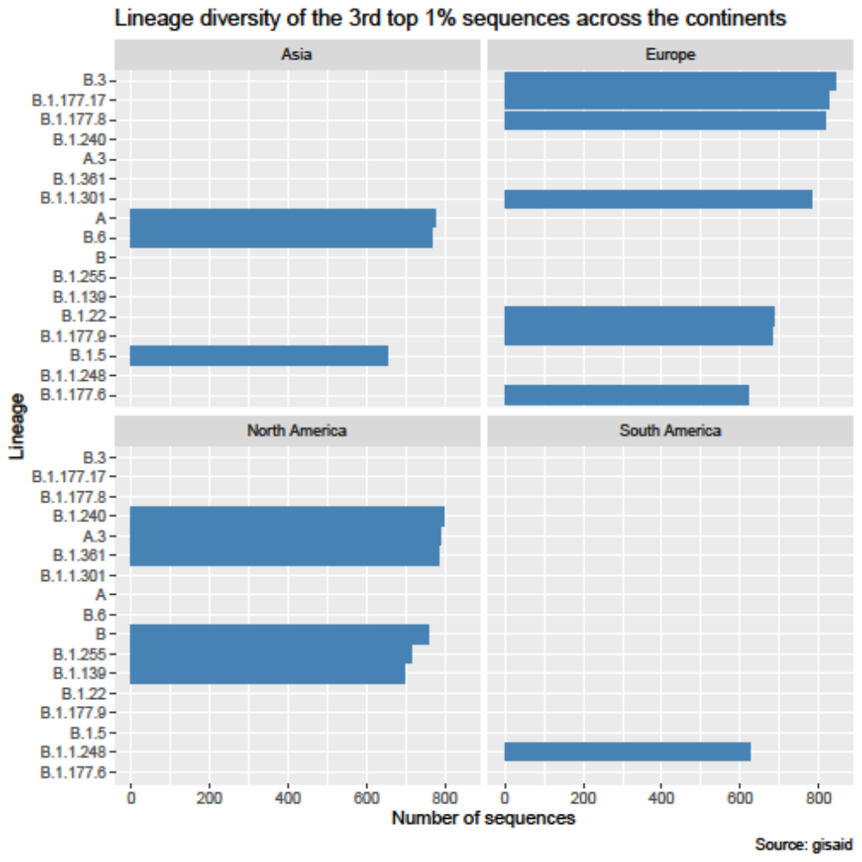
Figure 4D: The 4th top 1% lineages has just one lineage, B.1.177.6 in South America, three in Asia. Most of the lineages are in Europe and North America.
In Africa
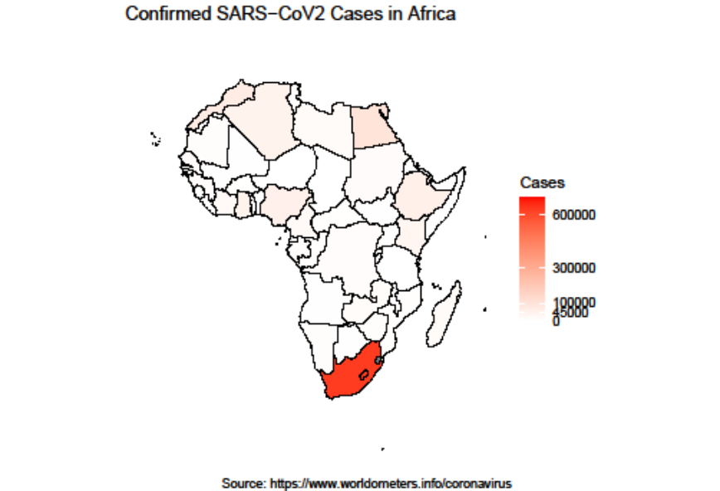
Figure 5: SARS-CoV2 reported cases in African countries. South Africa is seen to have the most number of SARS-CoV2 cases in Africa.

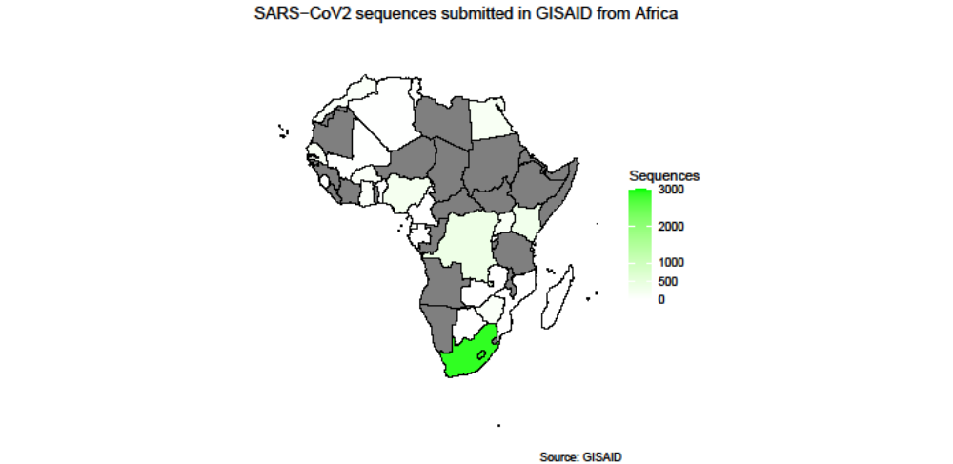

Figure 6: Sequences submitted on GISAID from Africa. Countries in gray have no submitted sequence in GISAID.

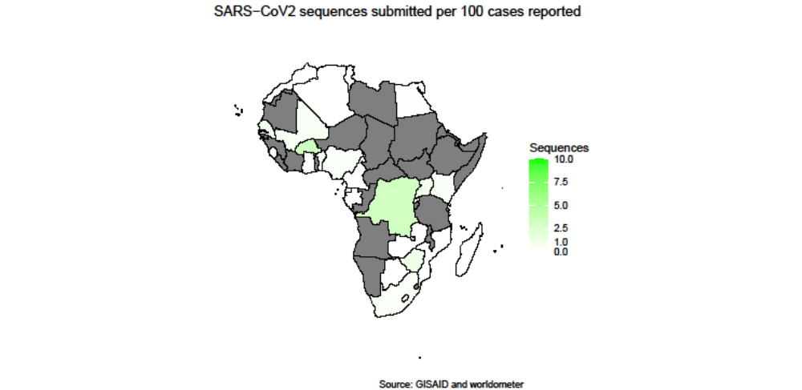
Figure 7: Sequences submitted per 100 SARS-CoV2 reported cases. Countries in gray have no sequence submitted on GISAID.

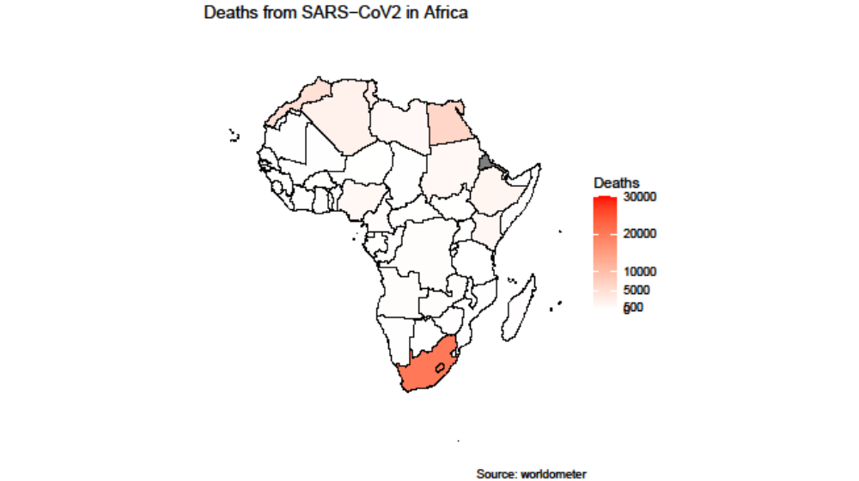

Figure 8: Reported deaths from SARS-CoV2 in Africa. Data for countries in gray are not available.
Figure 9: Deaths per 100 cases of SARS-CoV2 in Africa. Data not available for countries in gray.

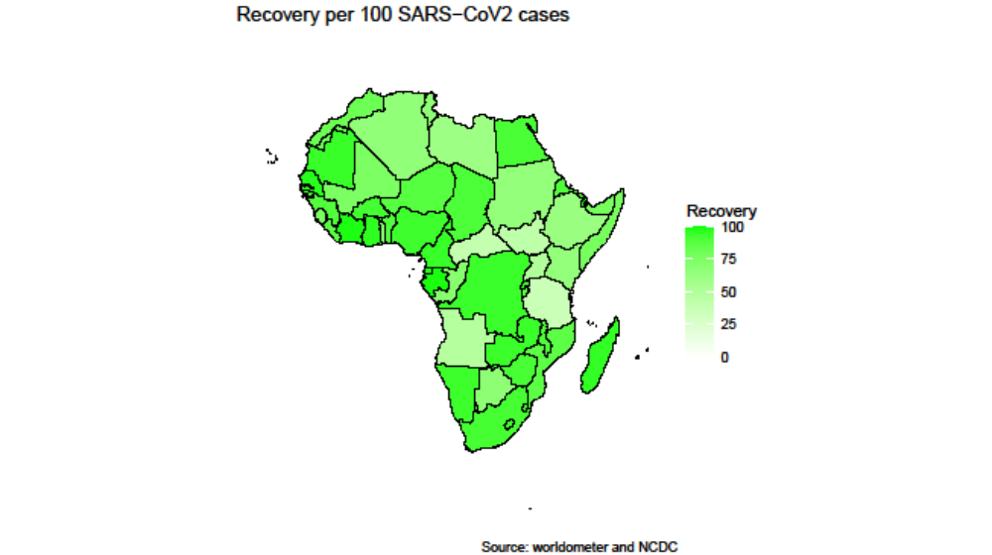
Figure 10: Number of persons who recovers per every 100 SARS-CoV2 reported cases in African countries. There are no data for countries in gray.

Figure 11: Number of persons tested for SARS-CoV2 per 100,000 of population in African countries.

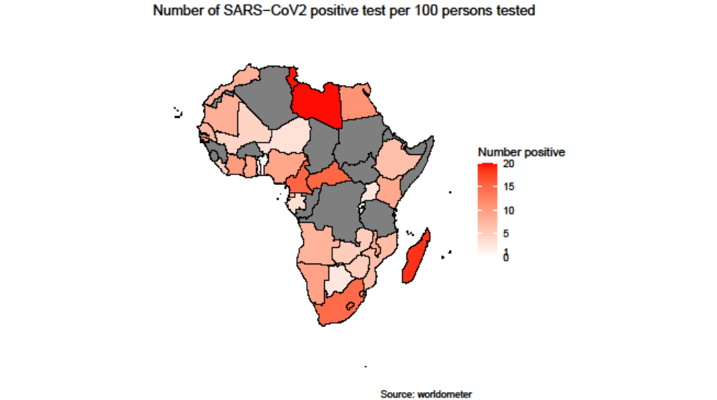
Figure 12: Number of positive patients out of every 100 suspected patients tested for SARS-CoV2. Data are unavailable for countries in gray.

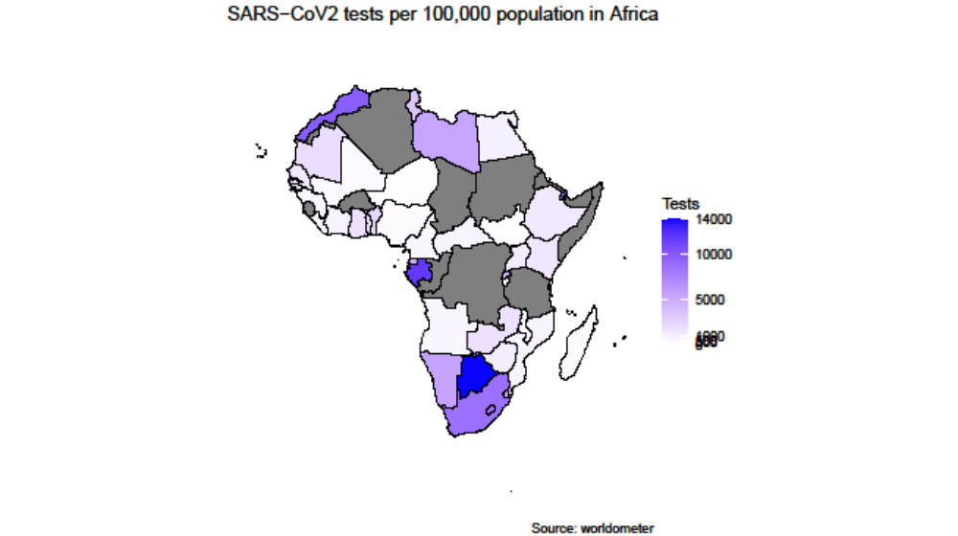
Figure 13: Number of SARS-CoV2 tests conducted per 100,000 population in African countries. Data unavailable for countries in gray.
BELOW ARE VARIOUS GRAPHS AND MAPS for SARS-CoV2 cases in Africa.
Figure A: Reported cases of SARS-CoV2 in African countries. South Africa is seen to have the most number of SARS-CoV2 cases in Africa.

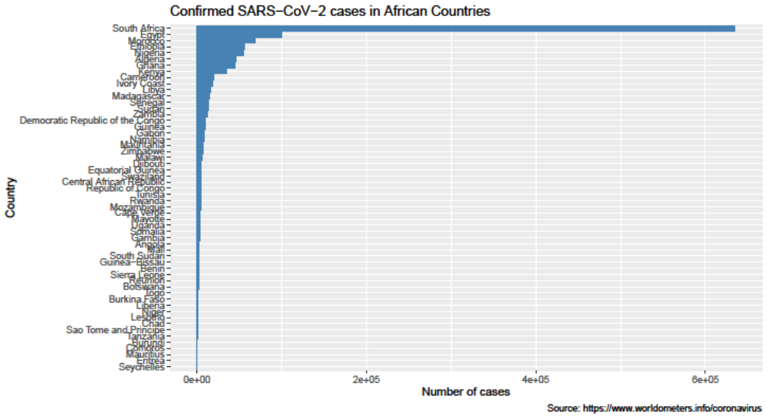
Figure B: Reported SARS-CoV2 cases in African countries. South Africa is seen to have the highest number of the virus with over 600,000 cases. It is followed by Egypt, Morocco and Ethiopia.

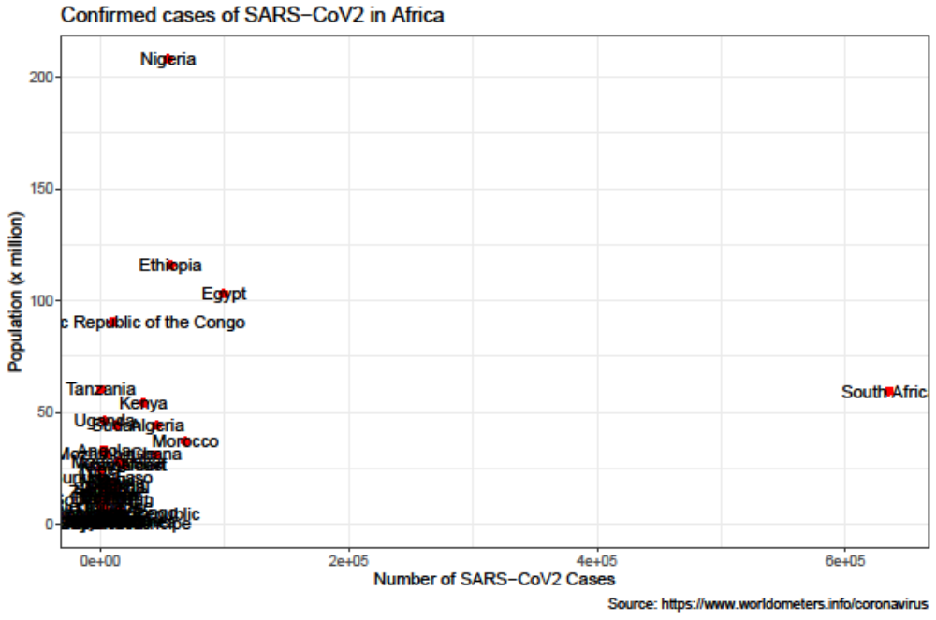
Figure C: SARS-CoV2 cases in African countries in relation to population in millions

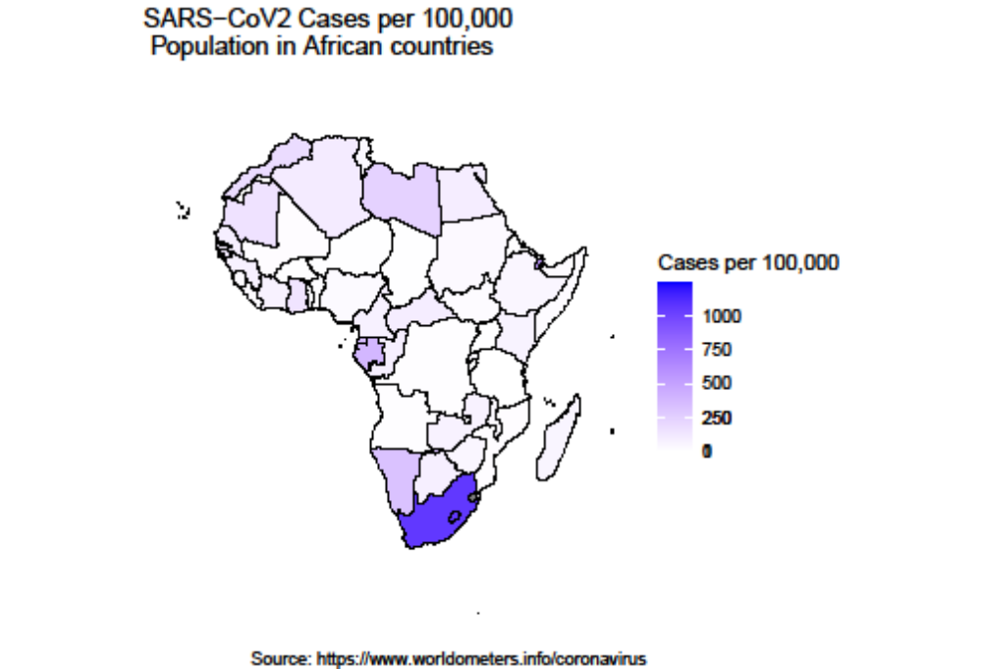
Figure D: SARS-CoV2 cases per 100,000 population in African countries

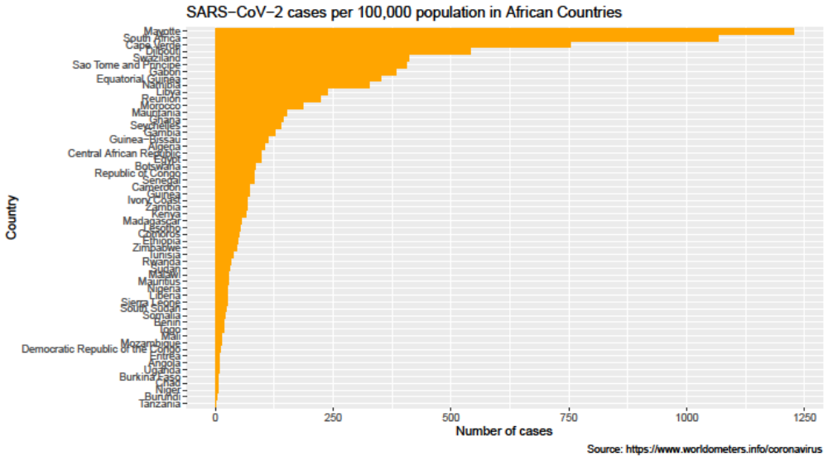
Figure E: SARS-CoV2 cases per 100,000 population in African countries.

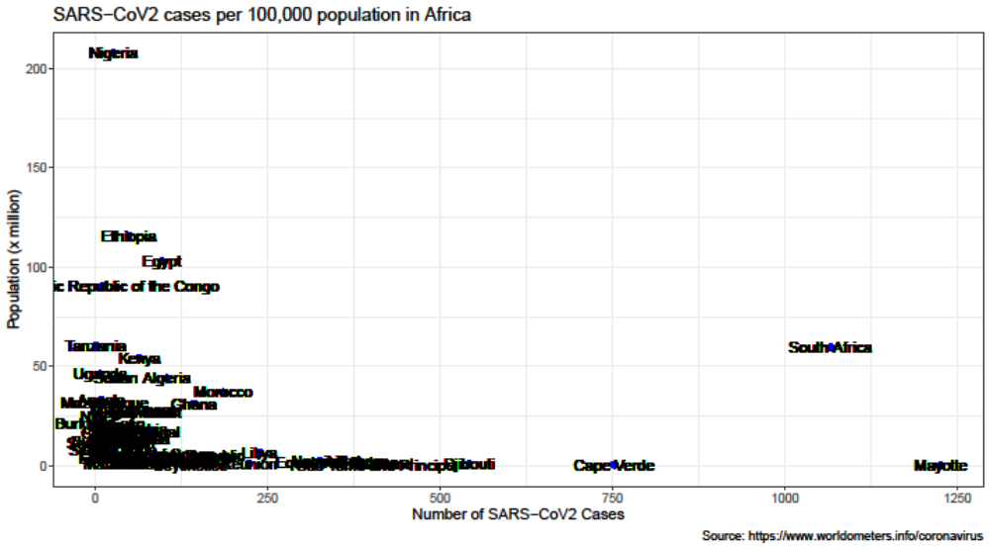
Figure F: SARS-CoV2 cases per 100,000 population, in relation to population, in African countries

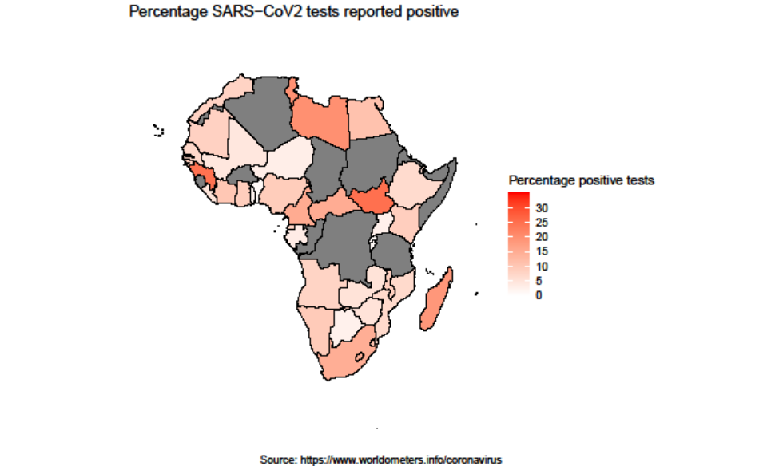
Figure G: Number of SARS-CoV2 positive tests out of every 100 tests conducted. No records of number of tests conducted for countries in black; which include Algeria, Sudan, Democratic Republic of the Congo, Republic of Congo, Somalia, Sierra Leone, Burkina Faso, Tanzania, Comoros, Eritrea and Western Sahara.

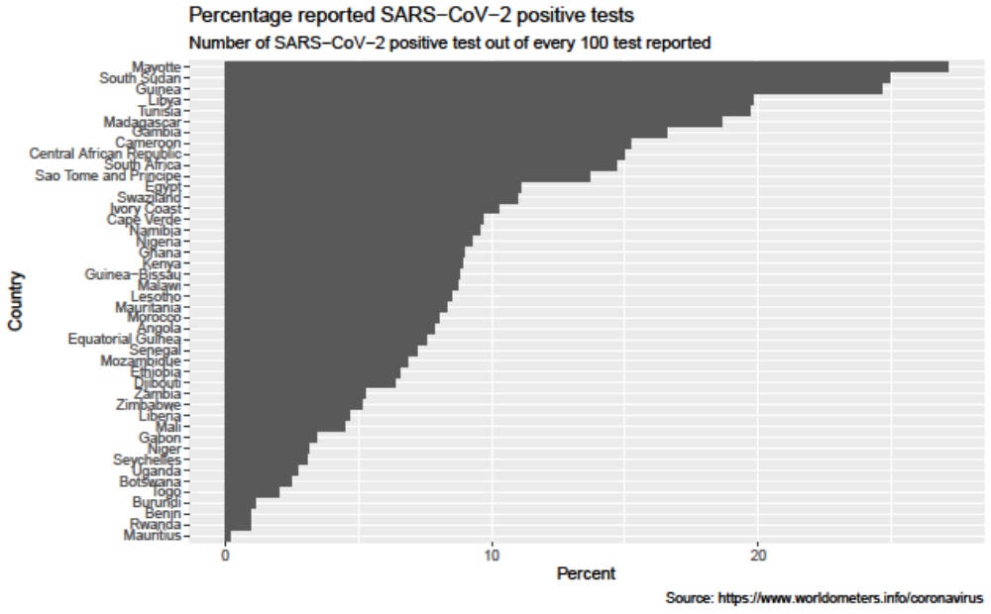
Figure H: Number of SARS-CoV2 positive tests out of every 100 tests conducted.

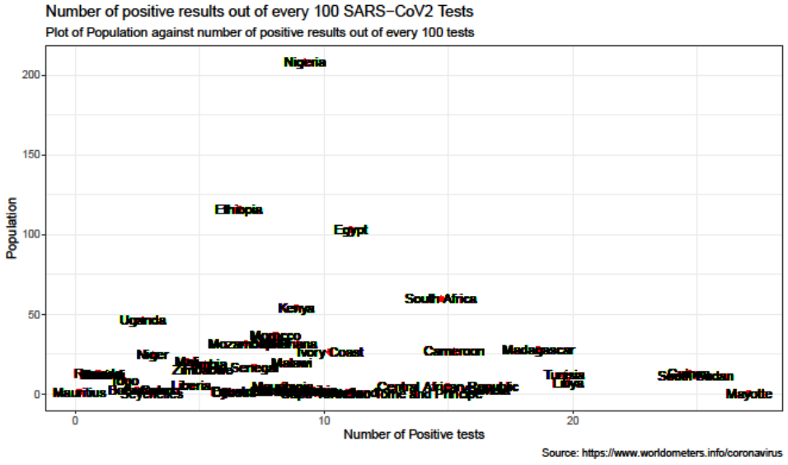
Figure I. Number of SARS-CoV2 positive tests out of every 100 tests conducted

SARS-CoV2 lineages distribution.
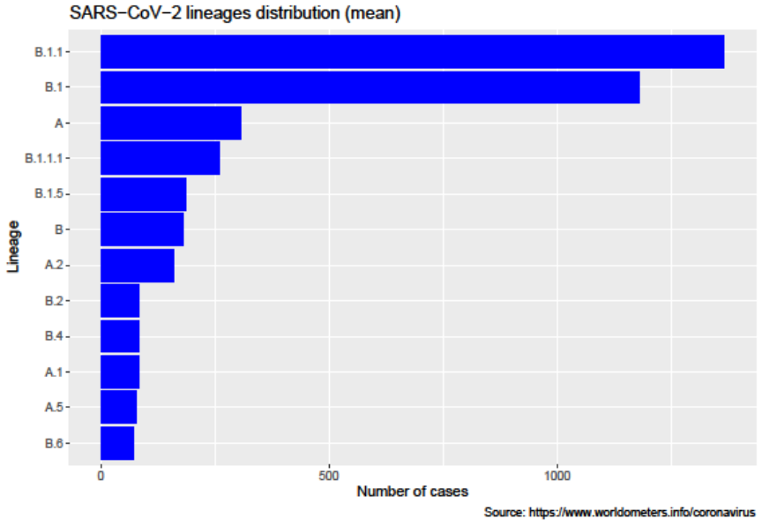

Figure J: SARS-CoV2 lineages.
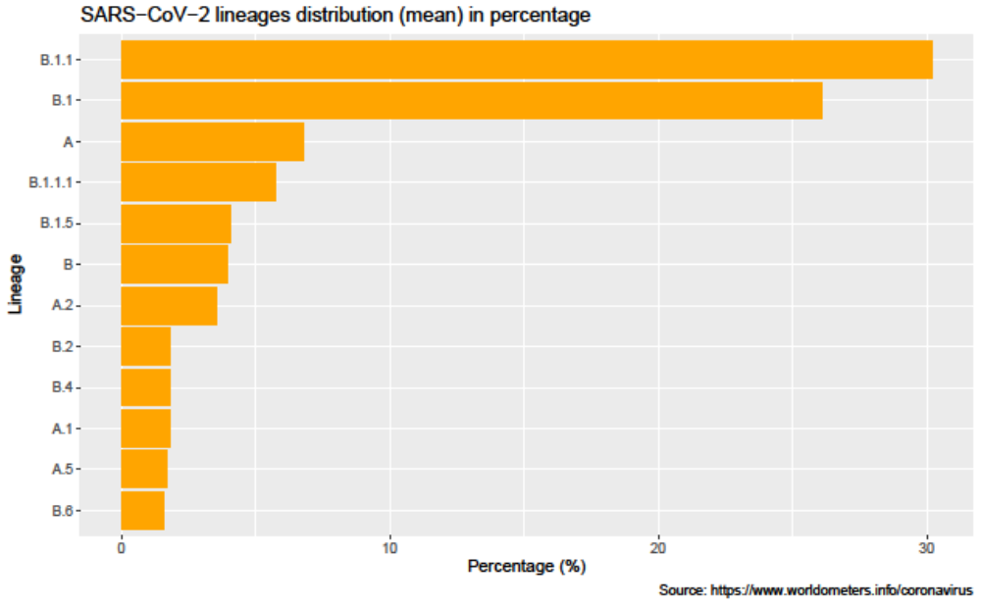
Figure K: SARS-CoV2 lineages in percentage.

However, we feel using the mean as cut off might not give a good representation. To have a better overview/knowledge of the lineage diversity, we decided to determine the 10th, 25th, 50th, 75th and 90th quantiles. We then chose the 75th quantile which is 4. Consequently, we filtered the lineages with a least 4 cases (75th quantile). Figures 5a and 5b show the bar chart for the 75th quantiles.

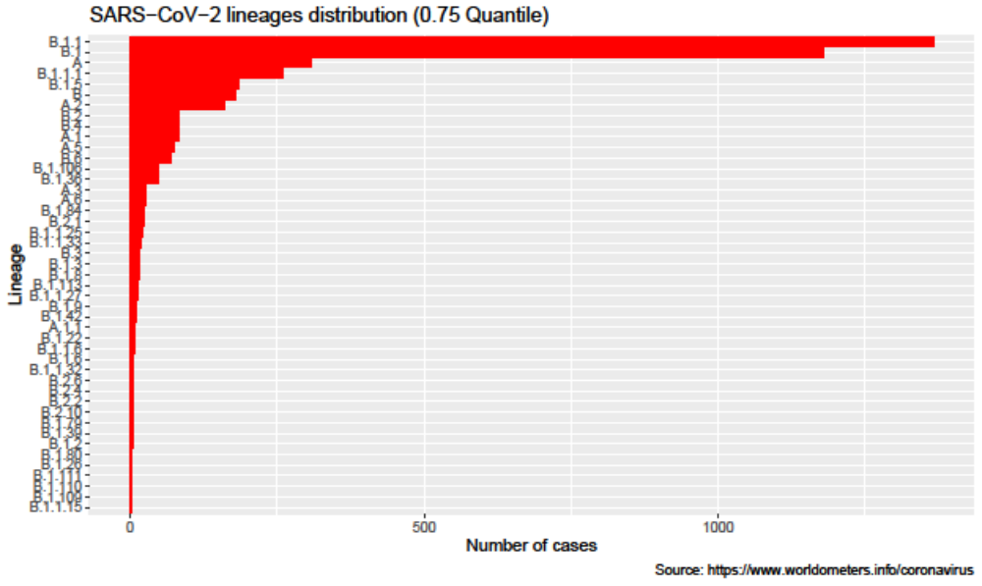
Figure L. SARS-CoV2 lineages (75 quantiles).

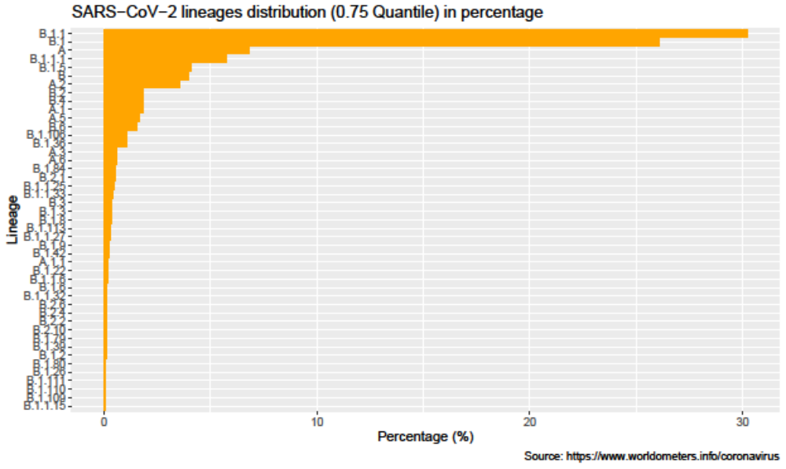
Figure M. SARS-CoV2 lineages (75 quantiles) in percentage.
To show the distribution of the lineages across the continents for easy comparison. Again the lineages were much for easy representation. We used different number of cases as cut off point to cut down the number of lineages that will be presented at a time. 26 cases and above gave a fair representation. However, it excluded Oceania which highest number of cases is 15. Hence, we reduced the cut off point to 15 so as to have Oceania included. Figures 6a and 6b show the distribution lineages which cases equals 15 and above, while figures 6c and 6d show lineages which cases are less than 15 across the continents.
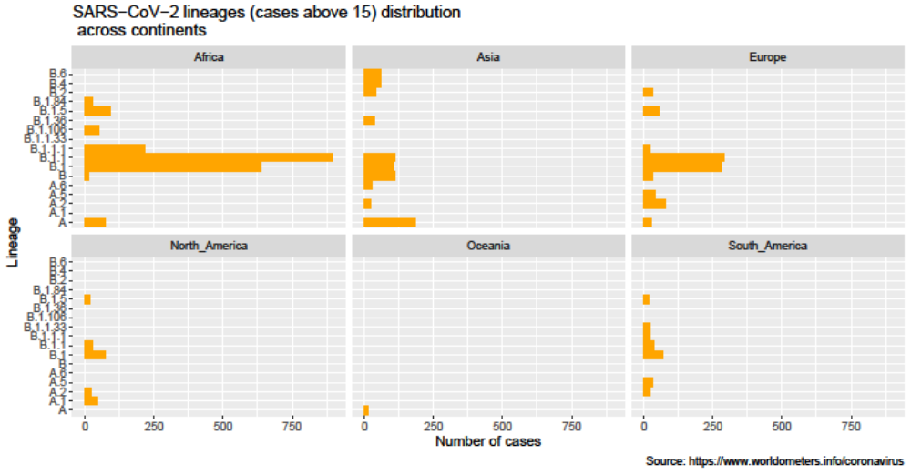
Figure N: SARS-CoV2 lineages (15 cases and above) across continents
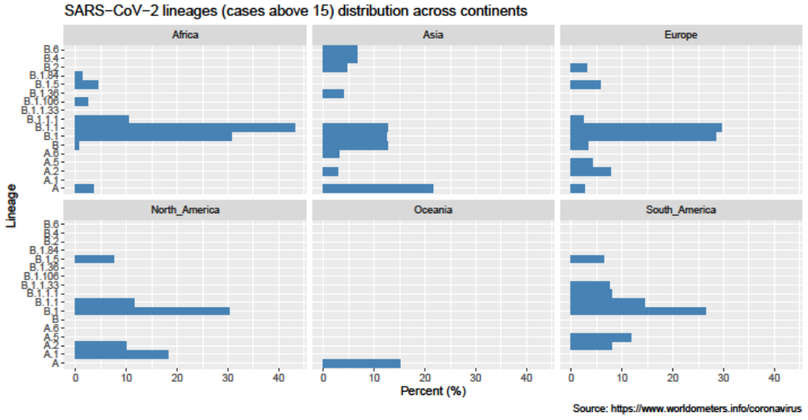
Figure O: SARS-CoV2 lineages (15 cases and above) across continents in percentage

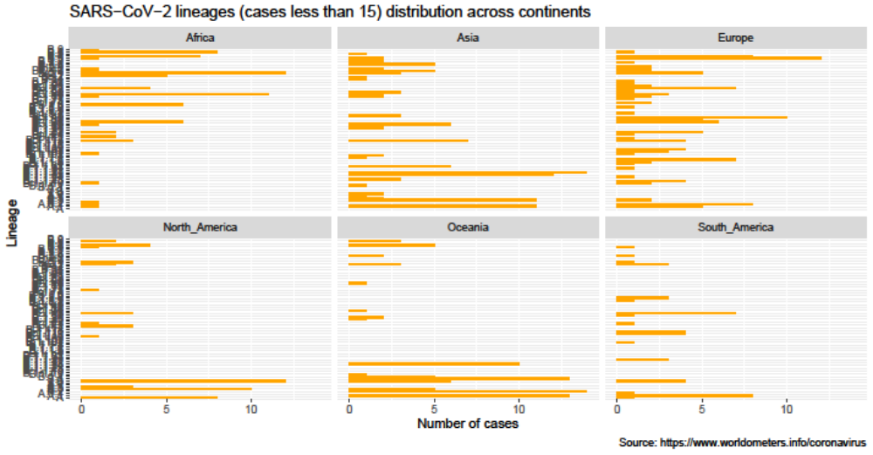
Figure P. SARS-CoV2 lineages (cases below 15) across continents
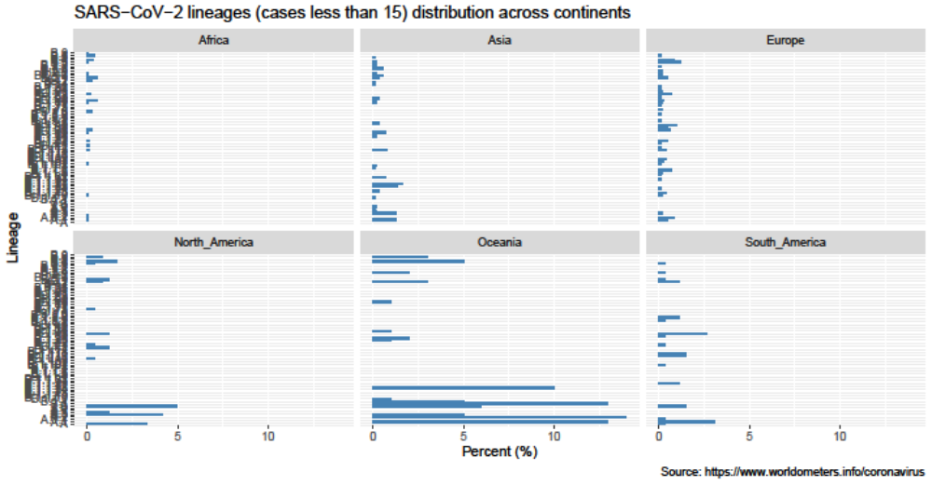
Figure Q. SARS-CoV2 lineages (cases below 15) across continents in percentage

To have a better view of the distribution of the SARS-CoV2 lineages diversity in each continent, we
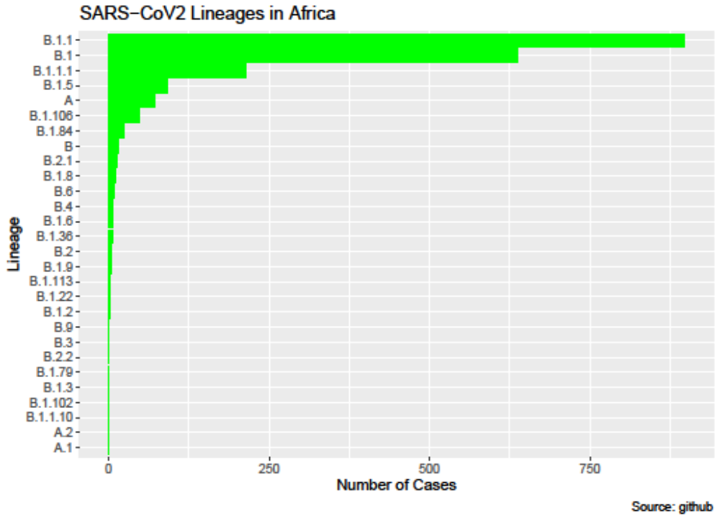
Figure R. SARS-CoV2 lineages in Africa
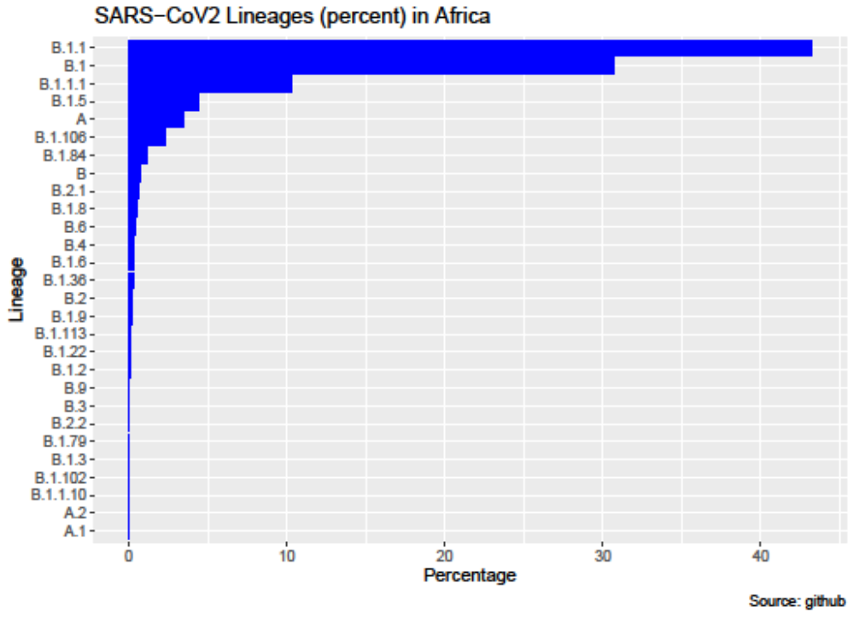
Figure S: SARS-CoV2 lineages in Africa in percentage
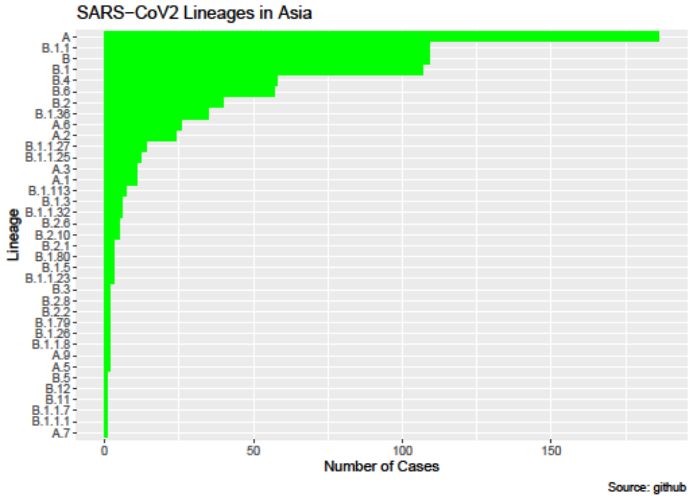
Figure T:. SARS-CoV2 lineages in Asia
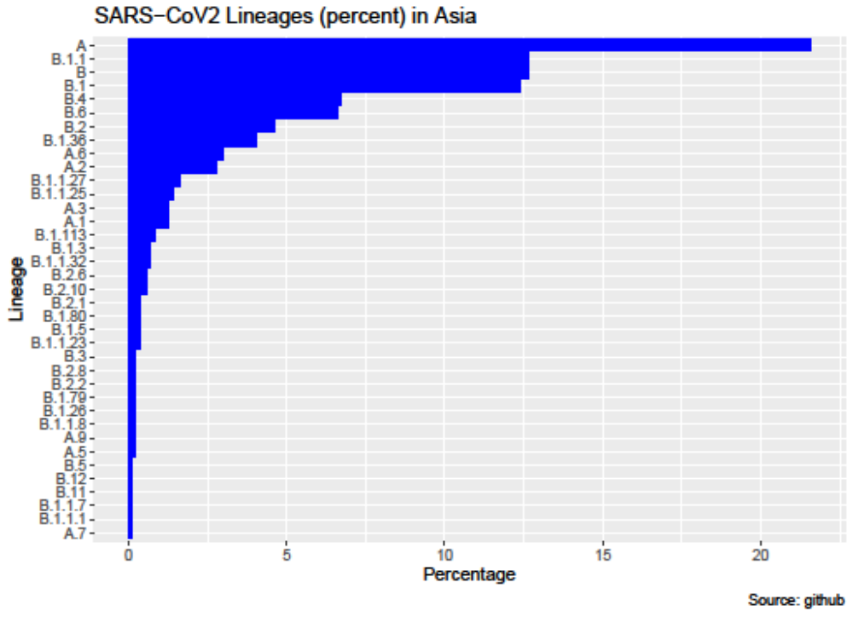
Figure U: SARS-CoV2 lineages in Asia in percentage
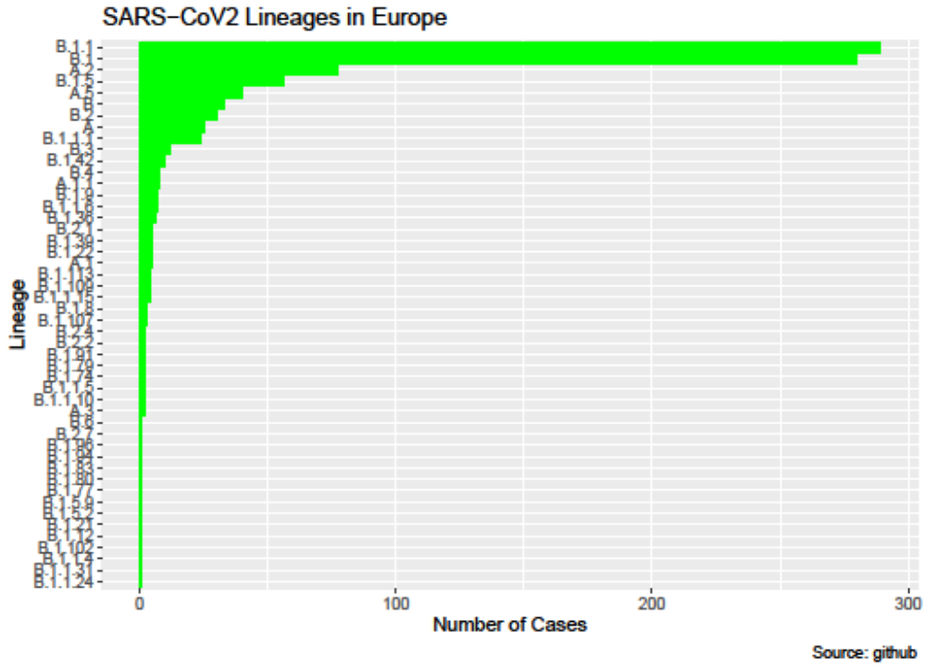
Figure V: SARS-CoV2 lineages in Europe
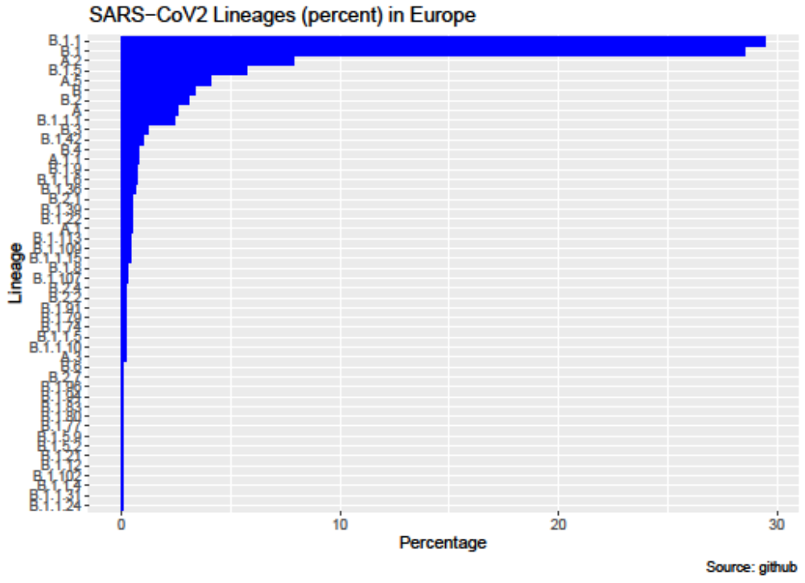
Figure W: SARS-CoV2 lineages in Europe in percentage
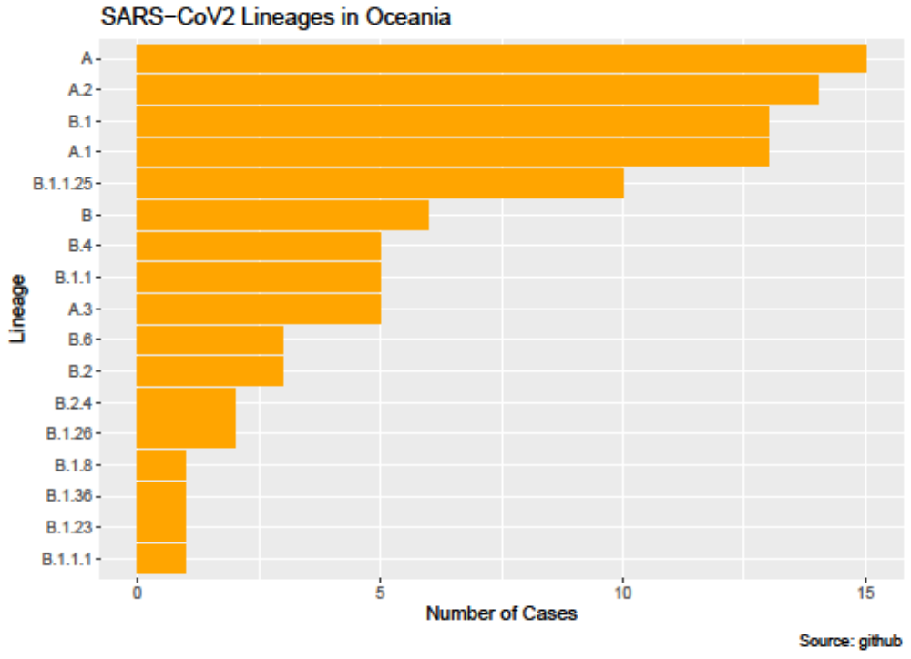
Figure X: SARS-CoV2 lineages in Oceania
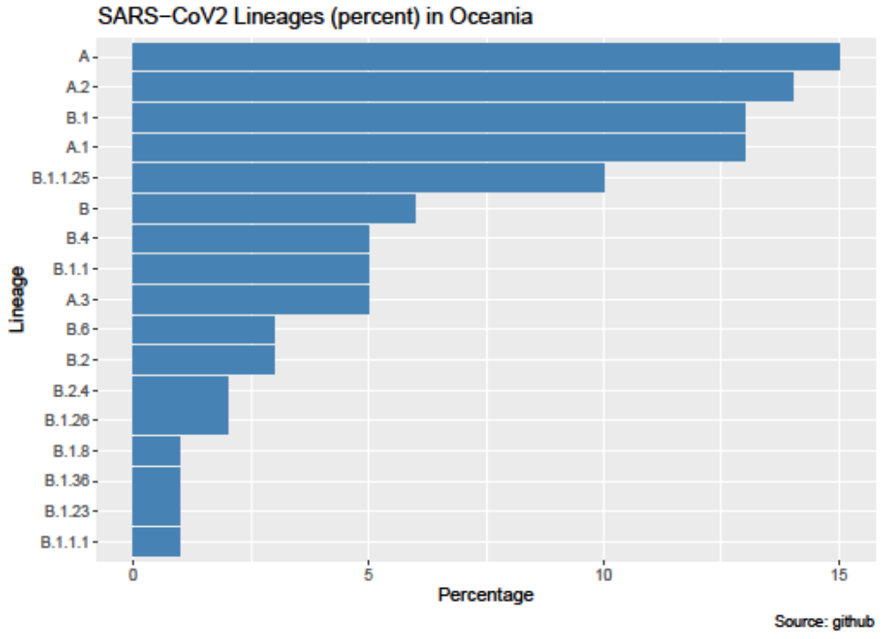
Figure Y: SARS-CoV2 lineages in Oceania in percentage
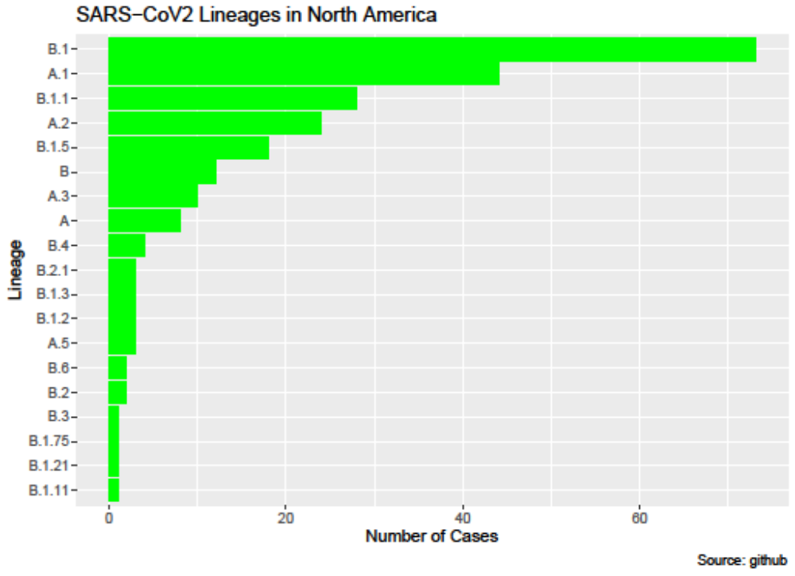
Figure Z: SARS-CoV2 lineages in South America
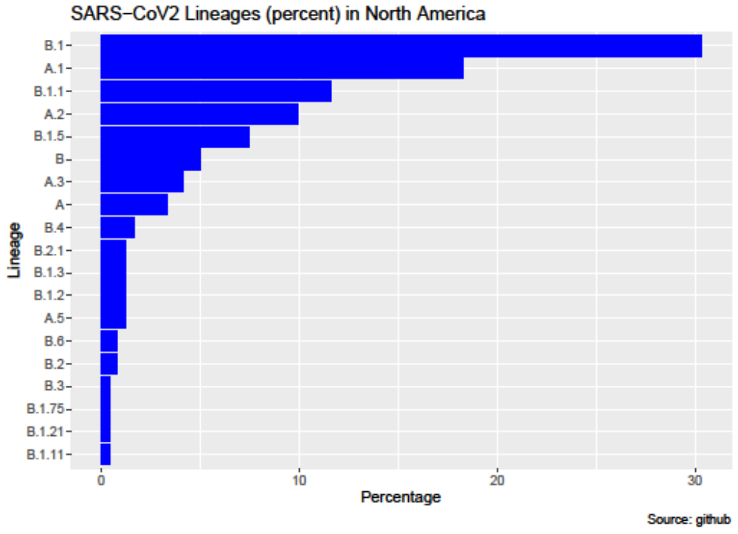
Figure AA: SARS-CoV2 lineages in South America in percentage
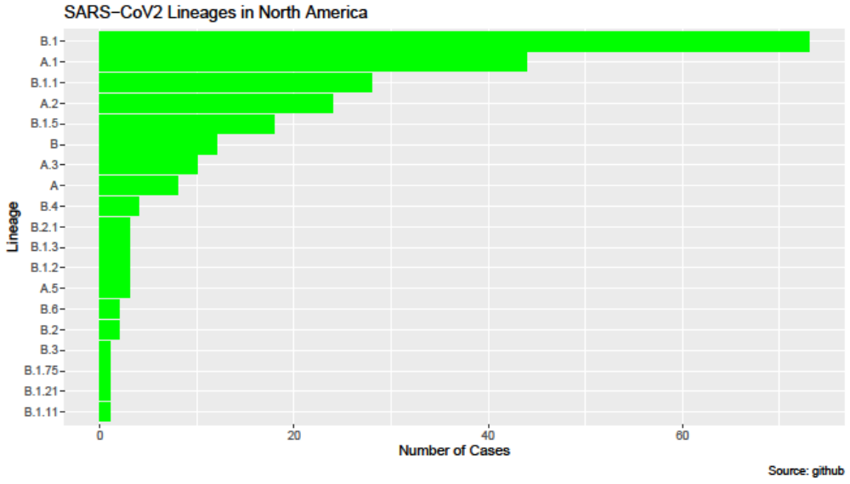
Figure AB: SARS-CoV2 lineages in North America
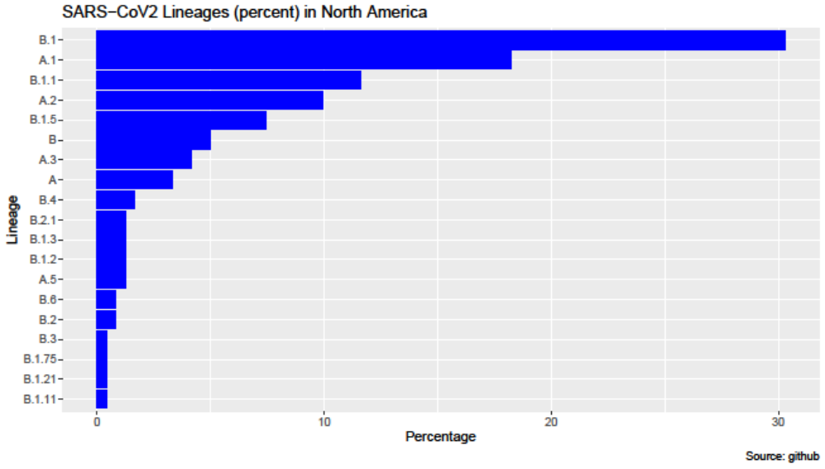
Figure AC: SARS-CoV2 lineages in North America in percentage

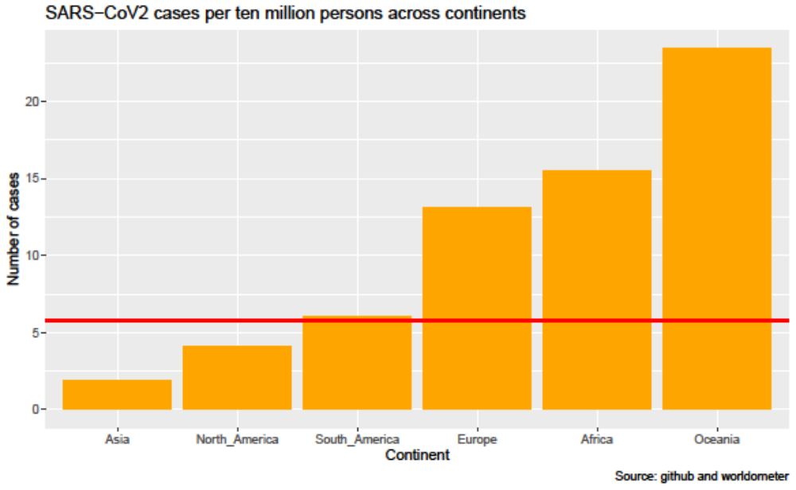
Figure AD: Number of cases per ten million persons in the different continents.
The global average of SARS-CoV2 cases per 10 million persons is 5.80. The horizontal red line in Figure 13a shows the global average of SARS-CoV2 cases per 10 million persons. The average SARS-CoV2 cases in Asia (1.86) and North America (4.07) is below the global average while that of Oceania (23.43), Africa (15.49) and Europe (13.12) greatly exceed the global average. The average in South America (6.08) is slightly above that of the global average.
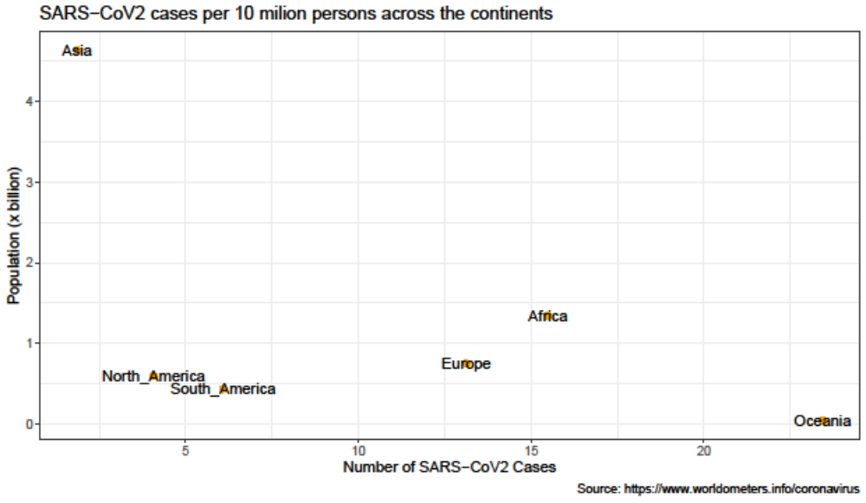

Figure AE: Number of cases per ten million persons with respect to population in the different continents

Reference
Auguie, B. (2017). gridExtra: Miscellaneous Functions for “Grid” Graphics. R package version 2.3. https://cran.r-project.org/package=gridExtra.
Becker, R. A., & Wilks, A. R. (2018). mapdata: Extra Map Databases (R package version 2.3.0). https://cran.r-project.org/package=mapdata
Deckmyn, A. B., Wilks, A. R., Ray Brownrigg, T., Homas, P. M., & Deckmyn, A. (2018). maps: Draw Geographical Maps (R package version 3.3.0). https://cran.r-project.org/package=maps
Erich, N. (2014). RColorBrewer: ColorBrewer Palettes (R package version 1.1-2). https://cran.r-project.org/package=RColorBrewer
Guangchuang, Y. (2020). scatterpie: Scatter Pie Plot (R package version 0.1.5). https://cran.r-project.org/package=scatterpie
Hadley, W., Romain, F., Lionel, H., & Kirill, M. (2020). dplyr: A Grammar of Data Manipulation, R package version 0.8.5. (0.8.5). https://cran.r-project.org/package=dplyr
Kahle, D., & Hadley Wickham. (2013). ggmap: Spatial Visualization with ggplot2. The R Journal, 5(1), 144–161. https://journal.r-project.org/archive/2013-1/kahle-wickham.pdf
Kassambara, A. (2019). ggcorrplot: Visualization of a Correlation Matrix using “ggplot2”. R package version 0.1.3. https://cran.r-project.org/package=ggcorrplot
Kassambara, A. (2020). ggpubr: “ggplot2” Based Publication Ready Plots. R package version 0.4.0. https://cran.r-project.org/package=ggpubr
McIlroy, D., Brownrigg, R., Thomas, P. M., & Bivand, R. (2020). mapproj: Map Projections. https://cran.r-project.org/package=mapproj
Peter DeWitt. (2020). qwraps2: Quick Wraps 2 (R package version 0.5.0). https://cran.r-project.org/package=qwraps2
R Core Team. (2020). R: A Language and Environment for Statistical Computing (4.0.0.). R Foundation for Statistical Computing, Vienna, Austria. https://www.r-project.org.
Roger, B., & Nicholas, L.-K. (2020). maptools: Tools for Handling Spatial Objects (1.0-2). https://cran.r-project.org/package=maptools
Wickham, H., & Jennifer Bryan. (2019). readxl: Read Excel Files (R package version 1.3.1). https://cran.r-project.org/package=readxl
Wickham, H., & Lionel Henry. (2020). tidyr: Tidy Messy Data (R package version 1.0.2). https://cran.r-project.org/package=tidyr

